Hannah Ozek

November 4, 2019

Semi-Report

**Problem 9. Experimental Methods**

Experiment 1:

Experiment 1 was the Double-Slit Experiment, this experiment was used to help the understanding of the wave-like nature of light. This was accomplished through the observation and the measurement of lights wave-like behavior. A diagram of the experiment can be seen below;

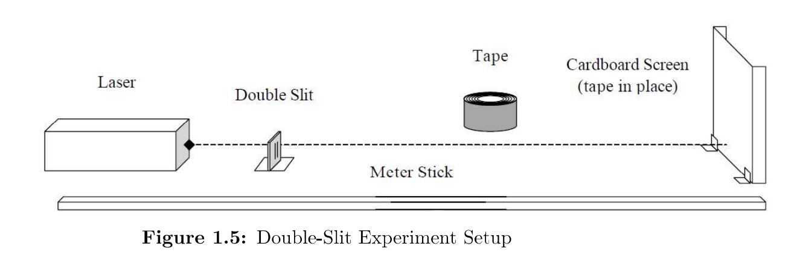

In the experiment, as can be seen in figure 1.5, a Helium-Neon laser was shined through a series of double-slit slides and the pattern was projected onto a piece of cardboard that was constant 1 meter away. With each slide, the width of the light projected changed, this was determined using a caliper to measure the width.

Experiment 2:

Experiment 2 was measuring the amount of data on a CD. Using the same laser as used in Experiment 1, the amount of information that can be stored on a CD can be found by measuring the spacing between the tracks. A figure of the experiment can be seen below;

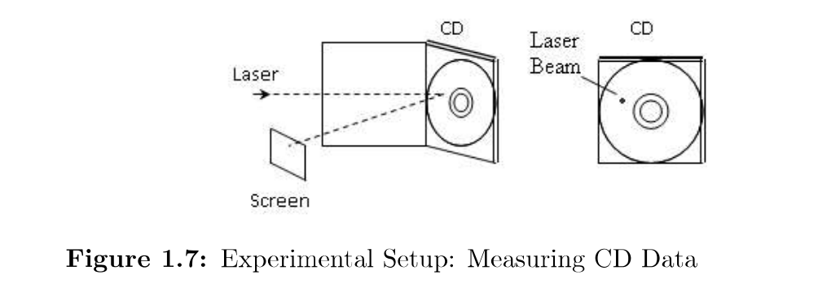

As it can be seen in figure 1.7, a compact disk was stood up using plastic supports and a Helium-Neon laser was pointed at it orthogonal using a mirror. This projected a pattern that was able to be measured on the screen.

**Problem 10. Results**

Experiment 1:

After values were measured in the experiment, the average of the fringe spacing was able to be determined. Using that average the best estimate and the total uncertainty was found for each double-slit. After these values were determined and recorded, the laser wavelength was able to be determined with uncertainty for each double-slit. By combining the results found, a single measurement was able to be taken for the generalized laser wavelength.

Experiment 2:

The data measured was x, the screen distance and $y_{m}$, the overall distance, and that was used to calculate $θ_{m}$, which is the angular position, with the derived equation. The track spacing, $h_{m}$, was also able to be calculated using the angular positions calculated and the laser wavelengths found in part one. After all these values were calculated, the percent difference between the value of h and the industry standard. Using all of this data we were able to find the maximum amount of information that can be put on the CD, which was calculated to be 400000000 bits.